Contribution title
Author1, Author2¹ , Author3
Abstract Each chapter should be preceded by an abstract (10–15 lines long) that summarizes the content. The abstract will appear online at www.SpringerLink.com and be available with unrestricted access. This allows unregistered users to read the abstract as a teaser for the complete chapter. As a general rule the abstracts will not appear in the printed version of a book.
1 Introduction
XL School of Hydraulics, similarly to previous events, is intended to provide a forum for scientists and engineers working in the field of broadly understood hydraulics. By bringing together experts (academics and practitioners) as well as young scientists, we hope to create a very good atmosphere for scientific debate and learning, and also to make this occasion an enjoyable experience for all participants.
The XL International School of Hydraulics will take place at the Tristan Hotel situated near Gdańsk, at the holiday village by the Baltic Sea - Kąty Rybackie. Its location at the Vistula Spit makes the village being surrounded by the sandy beaches of Gdańsk Bay in the north and natural coast of the Vistula Lagoon in the south.
XL International School of Hydraulics is organized by the Institute of Geophysics, Polish Academy of Sciences (IGF) and Institute of Hydro-Engineering, Polish Academy of Sciences (IBW) under the auspices of the International Association of Hydro- Environment Engineering and Research (IAHR) and the Committee for Water Resources Management of the Polish Academy of Sciences (KGW). Traditionally the School gathers many researchers from various countries, among them the European leaders in the field of hydraulics.
2 Instructions for authors
2.1 References
References in the text should consist of the Authors last names followed by year of publication in parentheses. For two authors, please give their last names separated by “and”. If more than two authors, please give the first author’s name followed by “et al.” and year, e.g. (Ghimire and Deng 2013; Parker et al. 2003). Please use the following format when necessary: Ghimire and Deng (2013), Parker et al. (2003).
All references cited in the text must be included in the reference list at the end of the paper. References should appear in alphabetical order at the end of the paper.
2.2 Figures and tables
Figures should be prepared at least in 350 dpi resolution. Please use color figures if necessary.
Textural content of a figure should be large enough – at least the font size of figure caption. Figure legends should be simple. Different line styles or colors should be used in the plots with multiple lines. Please make sure that your figures are clearly readable. Figures of poor quality will not be accepted.
All figures must be cited in the text. When referred to in the text, figure should be cited as Fig. 1, Figs. 3-5; if the word “Figure” begins a sentence, it should be written out in full.

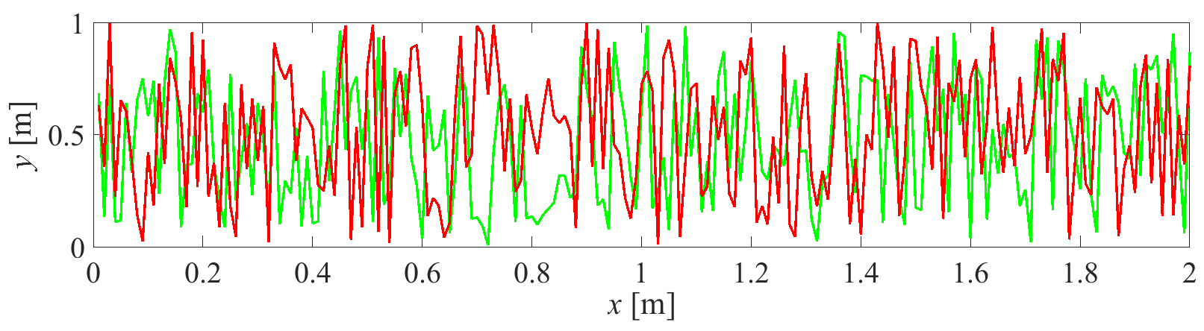
Fig. 1 Figure caption.

Please use the following table template:
Table 1 Table title
Column1 | Column2 | Column3 | Column4 | Column5
Row1 | value | value | value | value
Row2 | value | value | value | value
Row3 | value | value | value | value
Row4 | value | value | value | value

Please also note the following:
- number the tables consecutively using the chapter number (e.g., Table 1) and ensure that all the tables are cited in the text in the correct order;
- give each table a heading;
- do not use the space bar to separate columns, and do not use Excel to create tables.
2.3 Equations and lists
Equations should be numbered consecutively. The equation number is to be placed at the extreme right side as shown in Eq. (1). When referred to in the text, equation should be cited as Eq. (1), Eqs. (3)-(5); if the word “Equation” begins a sentence, it should be written out in full.
(1)
where t – time [s], T(x, t) – time-averaged water temperature [°C], x = (x, y, z) – position vector [m], x – longitudinal coordinate [m], y – transversal (lateral) coordinate [m], z – vertical coordinate [m], v(x) = (v_{x}, v_{y}, v_{z}) – time-averaged velocity vector [m s⁻¹], D_{M}(x) – molecular heat diffusion tensor [m² s⁻¹], D_{T}(x) – turbulent heat diffusion tensor [m² s⁻¹], Q – source function describing additional heating or cooling processes.
Please note:
- the use of SI units is mandatory;
- all units should be displayed using exponential formatting and typeset using normal font (not italic or bold), multiplication of units should be indicated by a space and division by negative exponents (e.g. m s^{–2});
- common, explicitly defined, functions should not be italic (e.g. Γ(y) for the gamma function, exp(a + b), sin(x));
- mathematical operators and constants should not be italic (e.g. dx, e = 2.718…);
- vectors and matrices and tensors should be bold (e.g. x = (x, y, z) – position vector, D – diffusion tensor);
- symbol for the decimal marker is the dot.
  - Technical Terms, Abbreviations
Ensure that the spelling of names, terms, and abbreviations is consistent, including in tables and figure legends. Abbreviations, except for very common ones, must be defined the first time they are used, and a list supplied with the manuscript. Chemical compounds should be named according to the systematic rules of the
IUPAC or Chemical Abstracts.
2.5 Sources
If you copy text passages, figures, or tables from other works, you must obtain permission from the copyright holder (usually the original publisher) for both the print and online format. Please enclose the signed permission with the manuscript. Please be aware that some publishers do not grant electronic rights for free and that Springer will not be able to refund any costs that may have been incurred in receiving these permissions.
Acknowledgements: This study has been financed by … .
References
Ghimire B, Deng Z (2013) Event flow hydrograph-based method for modeling sediment transport. Journal of Hydrologic Engineering 18(8): 919-928
Mrokowska MM, Rowiński PM, Kalinowska MB (2015) A methodological approach of estimating resistance to flow under unsteady flow conditions, Hydrology and Earth System Sciences, 19, 4041-4053
Parker G, Toro-Escobar CM, Ramey M, Beck S (2003) Effect of floodwater extraction on mountain stream morphology. Journal of Hydraulic Engineering 129(11): 885-895
Press WH, Flannery B, Teukolsky SA, Vetterling W (2007) Savitzky-Golay smoothing filters. In: Numerical Recipes in C. The art of scientific computing. Cambridge University Press, pp 650-655
Qu Z (2002) Unsteady open-channel flow over a mobile bed. Ph.D. thesis, No. 2688, École Polytechnique Fédérale de Lausanne, Lausanne, Switzerland
Rowiński PM, Czernuszenko W, Pretre JM (2000) Time dependent shear velocities in channel routing. Hydrological Sciences Journal 45(6): 881-895

Author1 (corresponding author), Author2 Institution, Address e-mail: corresponding.author@email.com
Author3 Institution, Address

